Activity:  Numeracy Practice:  Write how many tens and ones.  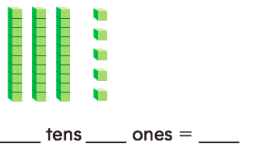  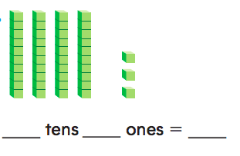 | Activity:  Numeracy Practice:  Hope has 2 sets of tens. She also has 5 ones. Which shows what Hope has?  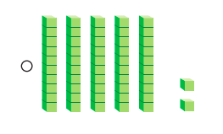  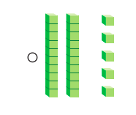  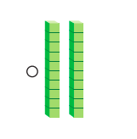 | Activity:  Numeracy Practice:  Draw a quick picture to show the number. Write how many hundreds, tens, and ones there are.  Moe has a group of 70 red feathers and 30 brown feathers.  ___hundred  ___tens  ___ones | Activity:  Use the data below to create a picture graph.  Numeracy Practice:  What number does this model show? ______  
  Fruit | Number of Fruits
  Apples | 12
  Mangos | 6
  Pineapples | 8
  Strawberries | 14
  Watermelons | 4
Checkpoint for Understanding:  What does your data show? | Checkpoint for Understanding:  What did you have most of? Least?  How do you know? | Checkpoint for Understanding:  What does your data show? | Checkpoint for Understanding:  What did you have most of? Least?  How do you know?

